

ASSIGNMENT-1

Topic: CLUSTERING

Name: Dixit Mj

USN No: 21BSR18041

Course: 6th Sem DSA

Jain university Jc Road

SAMPLE DATA: diabetic_data.csv

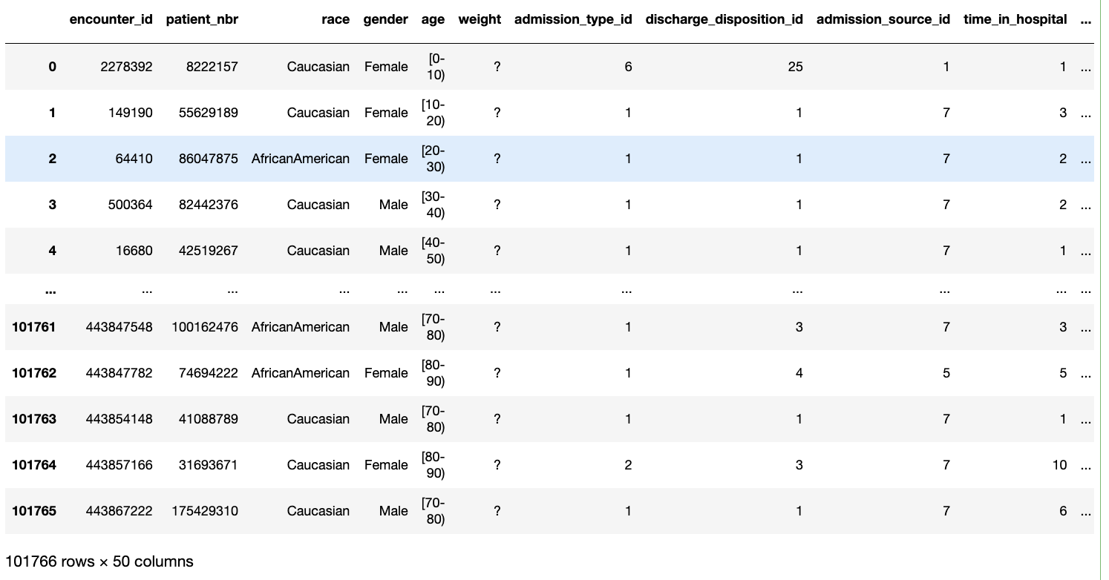

10 INSIGHTS FROM THE DATASET:

1. For Insulin and Number of inpatient

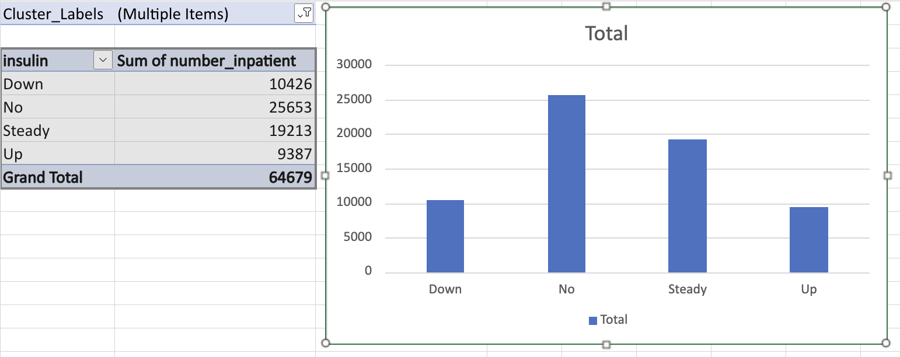

After considering all cluster labels, it is evident that the number of inpatients is 64679. Among them, the majority have not taken the insulin test, indicated by 'No.' The count of inpatients who have not taken the test is 25653 out of 64679.

1. For Race and Number of Outpatient

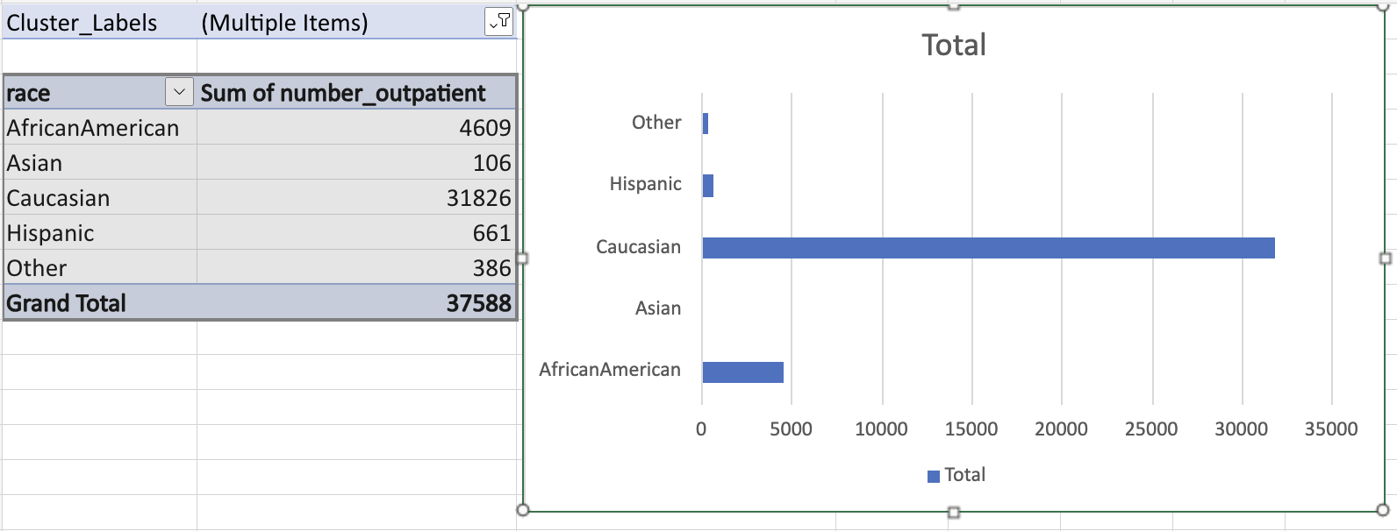

From the graph, we can see that most outpatients are Caucasian(31826), while the minority belongs to other races(386). The total number of outpatients is 37588.

1. For Race and Time in hospital

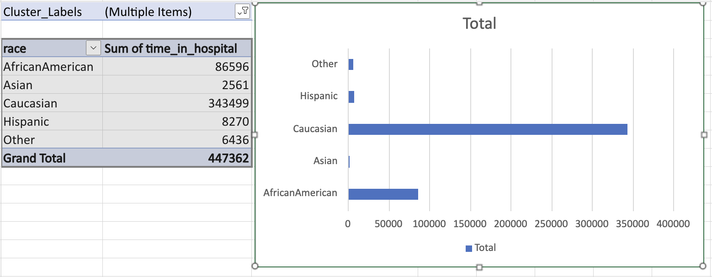

Here again, we can see that the Caucasian race is a majority in spending time in hospitals and the Asian race is the minority in time spent in hospital

1. For Gender and Time spent in Hosptial

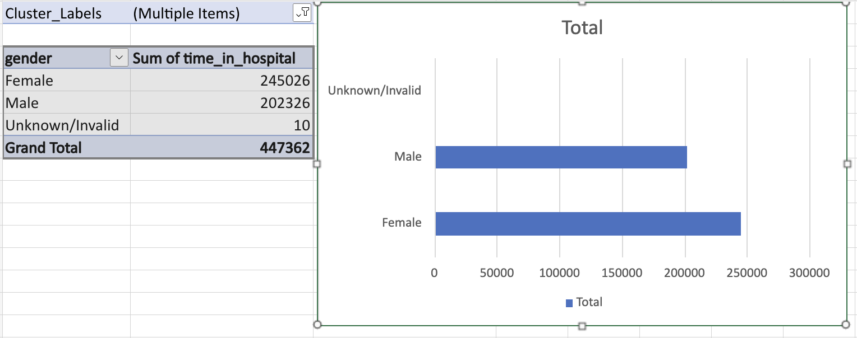

Based on the graph, it is evident that females spend more time in the hospital than males.

1. For Age and Number of emergencies

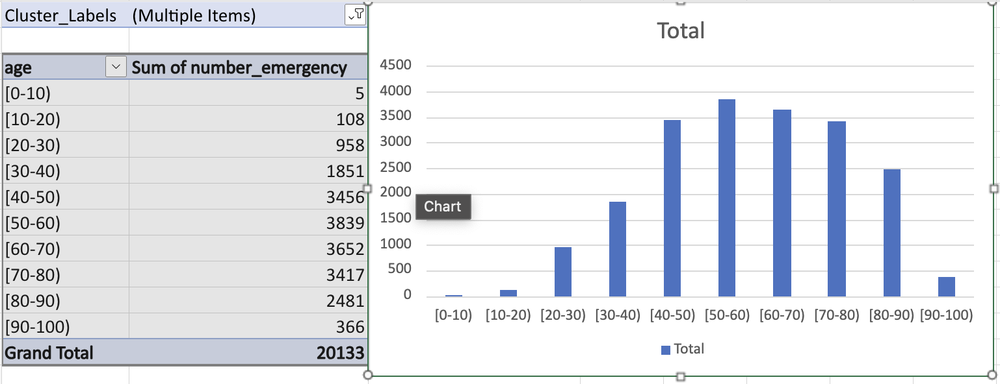

After analyzing the graph, we can conclude that the age group with the highest number of emergencies falls between 50-60 years old, and the age group with the least number of emergencies is between 0-10.

1. For Age and Number of medications

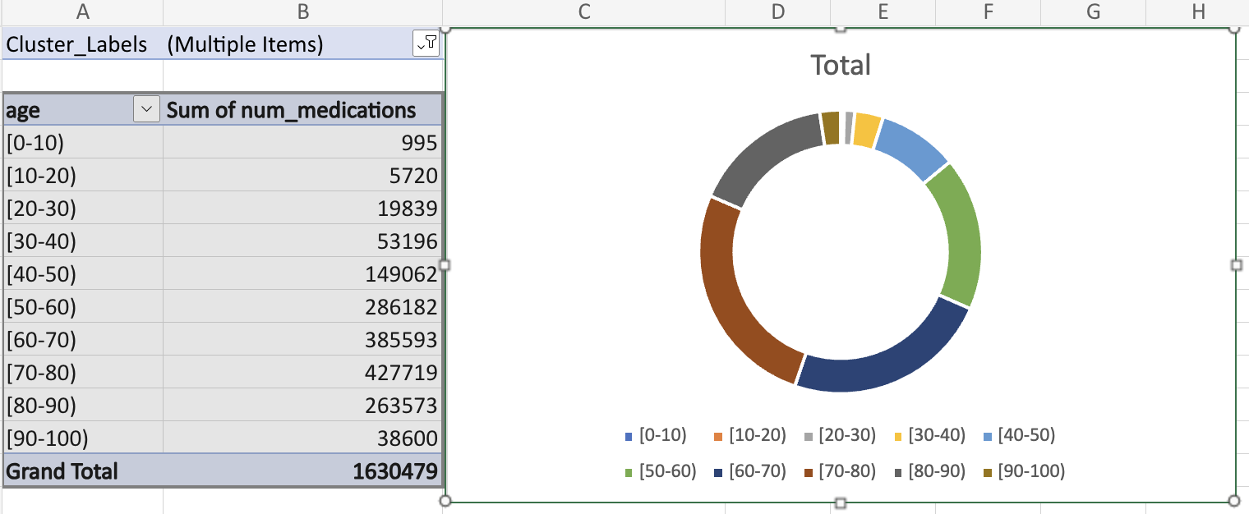

Based on the doughnut chart, we can see that people within the age range of 70-80 take more medications compared to those aged 0-10.

1. For Gender and number of medication

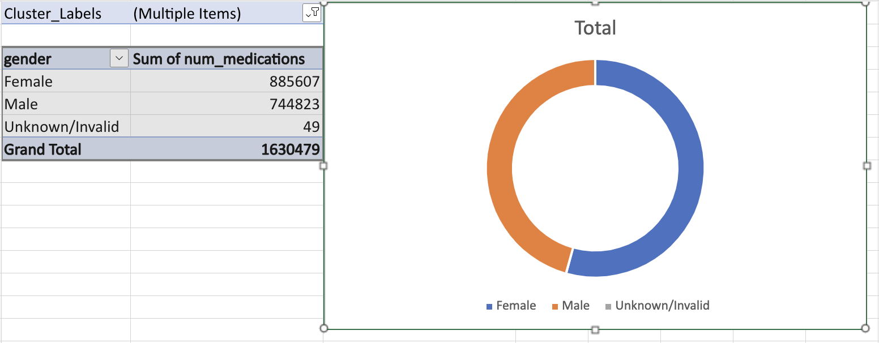

According to the doughnut chart, females take the majority of medications while the minority is unknown/Invalid.

1. For Age and Number of lab procedures

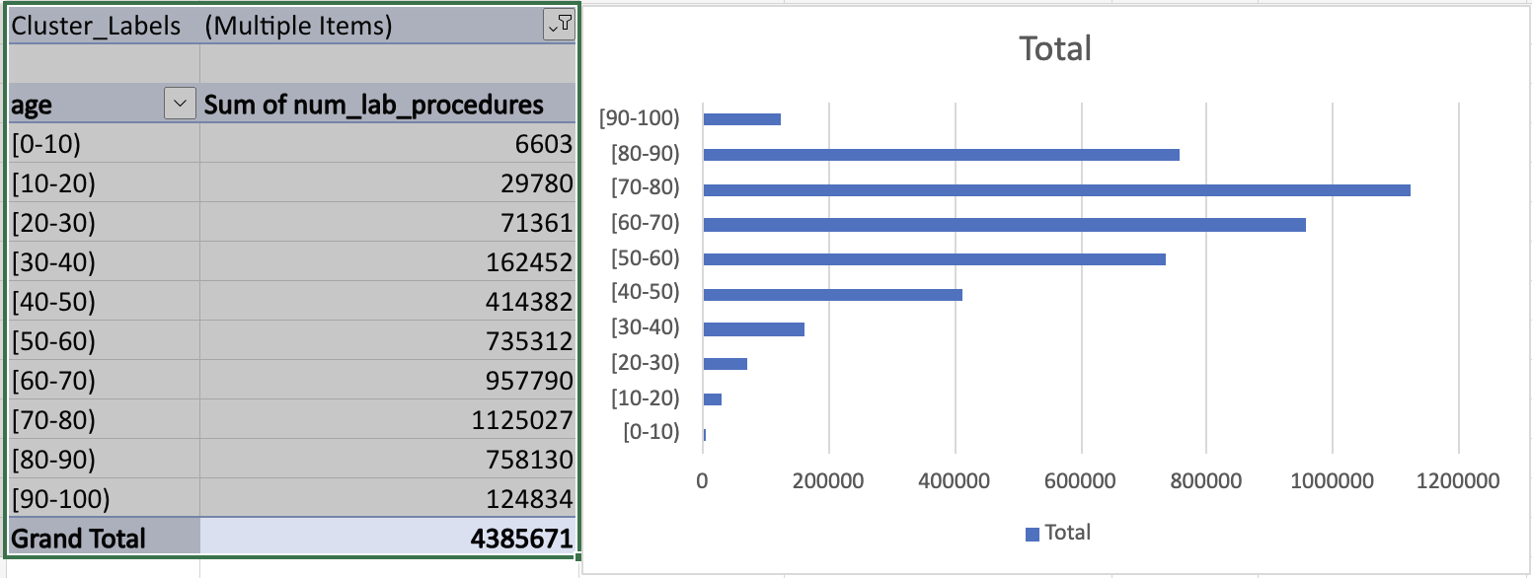

After analyzing the graph, we can see that individuals between the ages of 70-80 undergo the majority of lab procedures, while those between the ages of 0-10 undergo the least.

1. For Age and Insulin

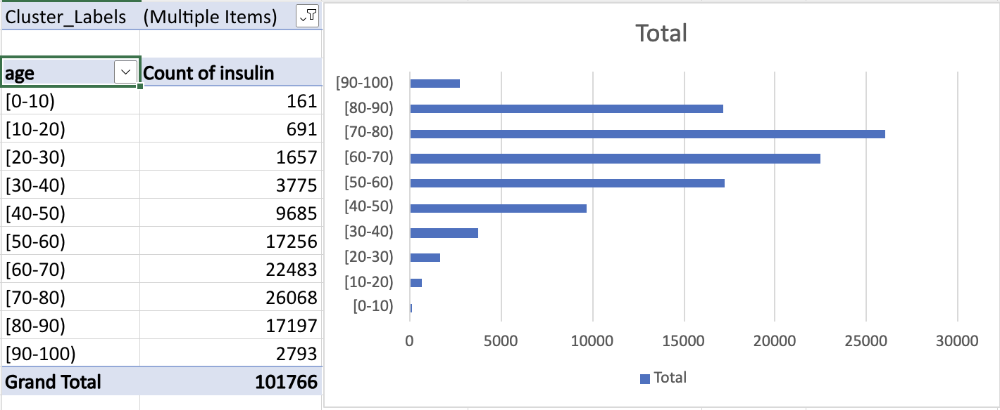

Based on the graph, it appears that the majority of people who take insulin tests fall within the age range of 70-80 years old, while the minority fall within the age range of 0-10 years old.

10. For Race and Count of Readmitted

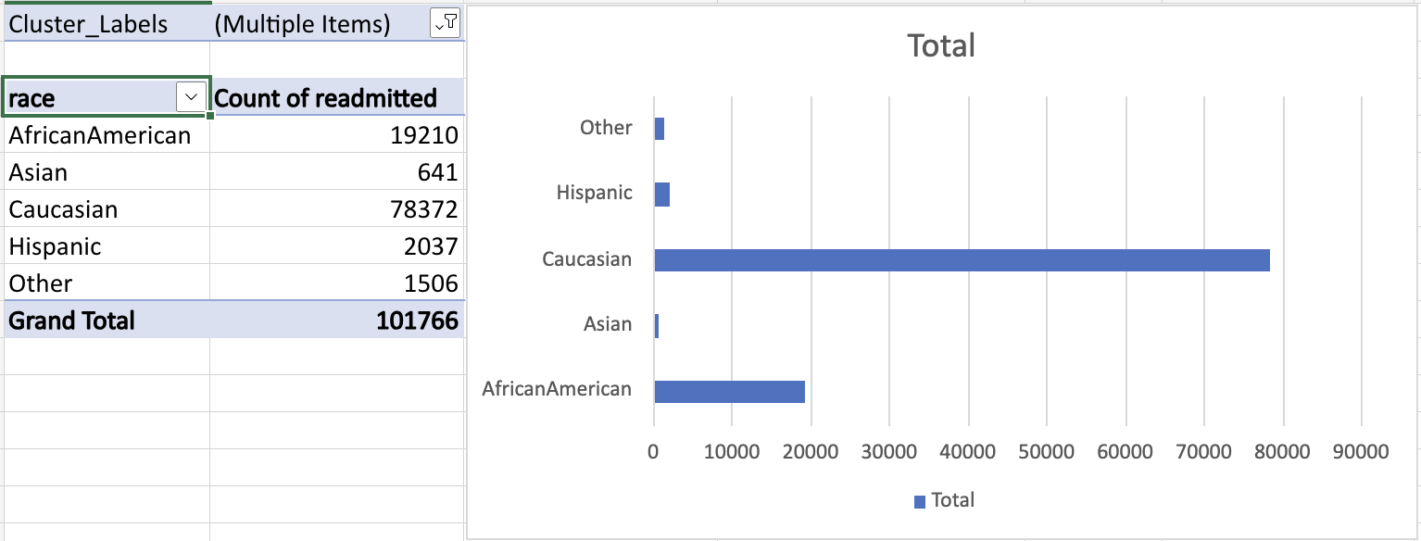

After analyzing the graph, it can be concluded that the majority of readmitted patients belong to the Caucasian race, while the minority belongs to the Asian race.